# Chameleon Website: Login/Sign up Use Case

The purpose of this use case diagram is to provide a high-level overview of the interactions and relationships between components on the Chameleon website Login/Sign Up page.

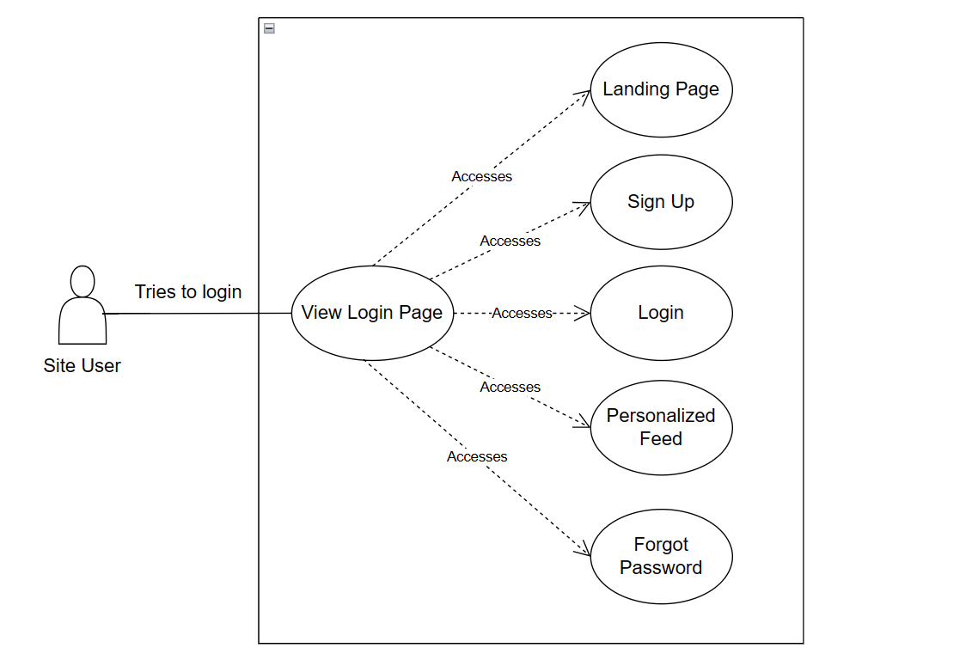

Relationships: lines to show the interactions between use cases.

**Identify Actors**: These are the primary actors interacting with the Chameleon website.

**Identify Use Cases**: These are the various actions or tasks the actors can perform.

1. Chameleon Website Login/Sign Up Page Use Case

Use Case Descriptions:

1. **Landing page:** Users arrive at the platform's landing page, where they are prompted to log in or sign up for a more personalized experience.
2. **Signup:**

* New users click on the "Sign Up" button to create an account.
* They enter their name, email address and a password.

1. **Login:** Returning users enter their email and password on the login page to access their accounts.
2. **Personalized Feed:** Upon successful login, users are redirected to their personalized feed.
3. **Forgot Password**: In case users forget their password, they can use the "Forgot Password" functionality to reset it. They receive an email with instructions to reset their password securely.